Defect Summary:

- Get Account Details API is /accounts/{accountNumber} is retrieving results but the status code is 302 whereas expected status code is 200
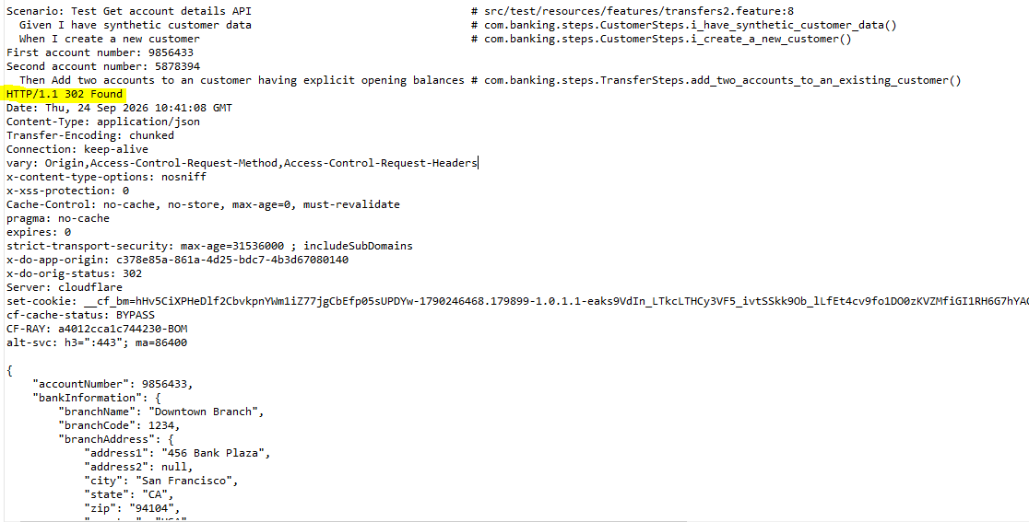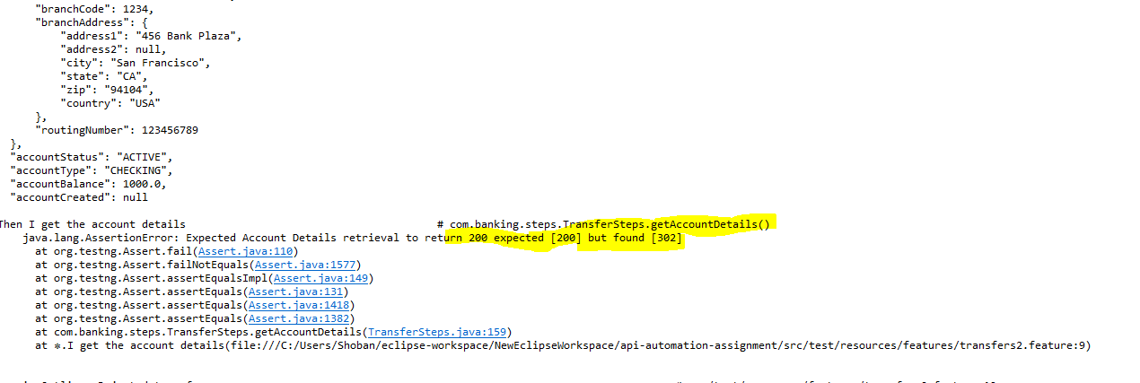

- When we do a fund transfer with Negative amount using the API /accounts/transfer/{customerNumber} then fund transfer should not happen and Error should be thrown…But the fund transfer happening with status code of 200
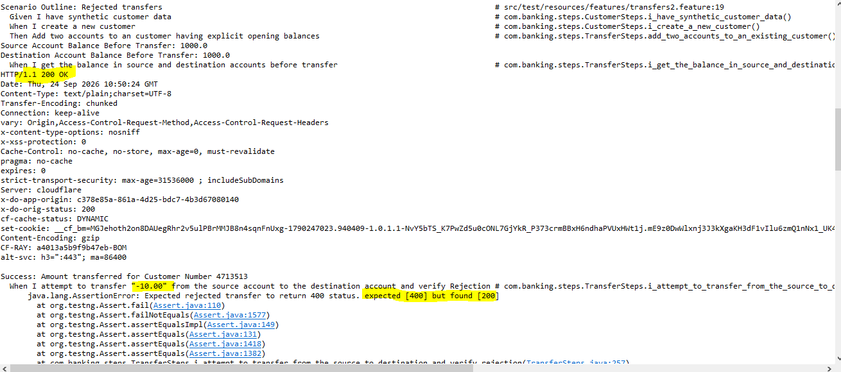
- When we are retrieving the non existing customer details using the /customers/{customerNumber} API then it should throw error but the status code is 200
